N
C
CLUB NATIONAL
“23rd” ANNUAL GOLF TOURNAMENT
June 27, 2024, at The Overlook Golf Course
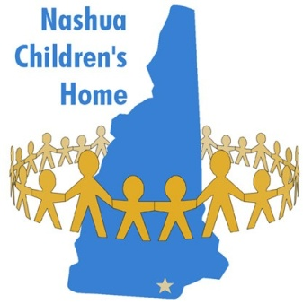
SPONSORSHIP OPPORTUNITY
To benefit Nashua Children’s Home
Federal Tax ID # 02-0222162

YES, I WOULD LIKE TO BE A SPONSOR. PLEASE CHECK ONE OF THE FOLLOWING SPONSORSHIP LEVELS.
Platinum
- Golf Carts- $2000 and Up (Name on Carts. Large Banner, Exclusive Rights, Top Listing on Donor Sheet)
- Steak Dinner- $2000 and Up (Large Banner, Table Signs, Exclusive Rights, Top Listing on Donor Sheet)
- Player Goodie Bags- $2000 and Up (Large Banner, Company Logo on Bag, Exclusive Rights, Top Listing on Donor Sheet)
Gold
- Hot Dog Stand- $1000 and Up (Large Banner, Exclusive Rights, Top Listing on Donor Sheet)
- Beer Carts- $1000 and Up (Name on Carts, Large Banner, Exclusive Rights, Top Listing on Donor Sheet)
- Putting Contest- $1000 and Up (Large Banner, Exclusive Rights, Top Listing on Donor Sheet)
Other Options
- Tee Signs- $150 and Up- (Company Listed on Placard and Posted on a Hole, Listed on Donor Sheet)
- Raffle and Auction Items Welcome- (Listed on Donor Sheet)
Please complete the back of this sheet and call if you want your donated items picked up @ (603)930-0680

Enclosed is my check in the amount of $ ___________
Name/Company/Organization: _____________________________________
Address: _______________________________________________________
City, State: _____________________________________________________
Phone: ______________________ Email: ____________________________
- I wish to remain anonymous (please check box).
Please return as soon as possible in order to be acknowledged in the printed materials.
Make check payable to: Club National Golf Tournament
Mail to: Club National NCH Golf Tournament, c/o Bob Boissonneault
127 Pine Street, Nashua NH 03060

DONOR SHEET

DONATED ITEM INFORMATION

Item Name: ___________________________________________________________________________________________________
Fair Market Value: ________________________________
Item Description: ____________________________________________________________________________________________
Item Restrictions: (can be used weekdays, holidays, etc.) ____________________________________________
__________________________________________________________________________________________________________________
Expiration Date? Y___/N___ Date: __________________
Item Is: __________Tangible ________Gift Certificate
Item Will Be: ______Dropped Off ______Picked Up ______Mailed

DONOR INFORMATION
Donor Is: ______Individual ______Business
Contact Name: _______________________________________________________________________________________________
Address: ______________________________________________________________________________________________________
City, State, Zip: ______________________________________________________________________________________________
Phone Number: _________________________________________________________
Email Address: _________________________________________________________
How Donor should be listed in the materials- by individual’s name/business/anonymous,
etc.) : __________________________________________________________________________________________________________
Solicitor/Committee Member Information
Name: ________________________________________________________________________________
Date Received: ______________________________________

Thank You!

